**PG Life**

**A PROJECT REPORT**

**for**

**Mini Project-I (K24MCA18P)**

**Session (2024-25)**

**Submitted by**

**<AMAN NAYAK>**

**( 202410116100021)**

**<NAME OF STUDENT>**

**(University Roll No……….. )**

**Submitted in partial fulfilment of the**

**Requirements for the Degree of**

**MASTER OF COMPUTER APPLICATION**

**Under the Supervision of**

**Ms. Divya Singhal**

### Assistant Professor



**Submitted to**

**Department Of Computer Applications**

**KIET Group of Institutions, Ghaziabad**

**Uttar Pradesh-201206**

**(december- 2024)**

**CERTIFICATE**

Certified that Aman nayak **202410116100021 ,Name of student <Enrollment No…..>** has/ have carried out the project work having “PG Life” (**Mini Project-I, K24MCA18P**) for **Master of Computer Application** from Dr. A.P.J. Abdul Kalam Technical University (AKTU**)** (formerly UPTU), Lucknow under my supervision. The project report embodies original work, and studies are carried out by the student himself/herself and the contents of the project report do not form the basis for the award of any other degree to the candidate or to anybody else from this or any other University/Institution.

**Ms. Divya Singhal Dr. Arun Kr. Tripathi**

**Assistant Professor Dean**

**Department of Computer Applications Department of Computer Applications**

**KIET Group of Institutions, Ghaziabad KIET Group of Institutions, Ghaziabad**

ABSTRACT:

This project presents a web-based platform designed to simplify the search for Paying Guest (PG) accommodations across four major Indian cities: Delhi, Mumbai, Bangalore, and Hyderabad. The website provides an intuitive interface that allows users to easily browse, filter, and view detailed information about PG options within their selected city.

The platform is built using **HTML, CSS, PHP, jQuery, and SQL**, ensuring a responsive, dynamic, and user-friendly experience. Upon selecting a city, users are presented with a comprehensive list of PGs, including key details such as the **PG name, price range, ratings, and address**. For further exploration, users can click a "View" button to access more detailed information about the selected PG, such as amenities, availability, contact details, and images.

Key features of the platform include:

* **City-based filtering** to streamline searches based on location.
* A structured database using **SQL** to manage PG listings and user interactions efficiently.
* Interactive and dynamic components implemented with **jQuery**, enhancing the user experience.
* A visually appealing design crafted with **HTML and CSS**, ensuring ease of navigation across devices.
* Backend functionalities powered by **PHP** to handle user requests, database queries, and dynamic content delivery.

This platform aims to address the challenges faced by individuals searching for suitable PG accommodations by offering a centralized, efficient, and user-centric solution.

**ACKNOWLEDGEMENTS**

Success in life is never attained single-handedly. My deepest gratitude goes to my project supervisor, **Ms. Divya Singhal** for her guidance, help, and encouragement throughout my project work. Their enlightening ideas, comments, and suggestions.

Words are not enough to express my gratitude to Dr. Arun Kumar Tripathi, Professor and Dean, Department of Computer Applications, for his insightful comments and administrative help on various occasions.

Fortunately, I have many understanding friends, who have helped me a lot on many critical conditions.

Finally, my sincere thanks go to my family members and all those who have directly and indirectly provided me with moral support and other kind of help. Without their support, completion of this work would not have been possible in time. They keep my life filled with enjoyment and happiness.

**Aman Nayak**

**<Name of Candidate>**

**…………**

**TABLE OF CONTENTS**

**Certificate**

**Abstract**

**Acknoledgements**

**1. Intoduction**

**1.1 Overview**

1.1.1 Background

1.1.1.1The Growing Need for PG Accommodations

1.1.1.2Challenges in Traditional PG Search Methods

1.1.2 Technological Advancements in Accommodation Platforms

1.1.2.1 The Role of Online Platforms in Bridging the Gap

**1.2 Purpose of PG Life**

1.2.1Addressing User Needs for a Seamless Search

1.2.2 Empowering Property Owners to Reach Tenants

**1.3 Objectives of PG Life**

**1.4 Scope of PG Life**

**1.5 Significance of PG Life**

**2. Feasibility Study/Literature Review**

**2.1 Feasibility Study/Literature Review**

**2.2 Existing Platforms and Competitor Analysis**

**2.3 Technological Feasibility**

**2.4 Market Feasibility**

**2.5 Literature Review on Digital Rental Platforms**

**3. Project / Research Objective**

**4. Hardware And Software Requirements**

**4.1 Hardware Requirement**

**4.2 Software Requirement**

**5. Project Flow / Research Methadology**

**5.1 Requirement Analysis**

**5.2Feasibility Study**

**5.3 System Design and Architecture**

**5.4 Development**

**5.5 Testing and Validation**

**5.6 Deployment**

**5.7. Post-Deployment Monitoring and Maintenance**

**5.8. Data Analysis and Reporting**

**5.9. Use case diagram**

**5.10. Sequence Flow**

**1. Introduction**

**1.1 Overview**

**1.1.1 Background**

**1.1.1.1 The Growing Need for PG Accommodations**  
In today’s urbanized and fast-paced world, there is an increasing demand for affordable and accessible paying guest (PG) accommodations. Students, working professionals, and frequent travelers often migrate to metropolitan cities in search of education, employment, or better living opportunities. Traditional housing options, such as apartments, are often costly and require long-term commitments, making them less feasible for individuals seeking temporary living spaces. This has led to a surge in the need for PG accommodations that offer cost-effective, flexible, and convenient living solutions.

**1.1.1.2 Challenges in Traditional PG Search Methods**  
Despite the growing demand for PGs, the process of finding suitable accommodations remains cumbersome and inefficient. Traditional methods, such as relying on word-of-mouth recommendations, local advertisements, or unverified listings, often lead to incomplete or inaccurate information. Additionally, the lack of transparency in terms of pricing, amenities, and property conditions poses a significant challenge for seekers. Visiting multiple properties physically is time-consuming and exhausting, making the search process even more stressful.

**1.1.2 Technological Advancements in Accommodation Platforms**

**1.1.2.1 The Role of Online Platforms in Bridging the Gap**  
Technology has revolutionized the way individuals find accommodation. Online platforms now play a pivotal role in connecting property owners and seekers, offering detailed property insights, virtual tools, and secure communication features. By leveraging digital solutions, PG Life addresses the limitations of traditional search methods, providing users with an efficient, transparent, and user-friendly platform to search for PG accommodations.

**1.2 Purpose of PG Life**

**1.2.1 Addressing User Needs for a Seamless Search**

The primary purpose of PG Life is to simplify the accommodation search process for PG seekers. The platform is designed to cater to individuals looking for reliable, affordable, and accessible housing solutions. By offering advanced search filters, verified listings, virtual property tours, and tenant reviews, PG Life ensures a seamless and stress-free experience for users.

**1.2.2 Empowering Property Owners to Reach Tenants**

PG Life also aims to empower property owners by providing them with a platform to market their PG spaces effectively. By listing properties with complete details, images, and amenities, property owners can attract genuine tenants, reduce vacancy periods, and enhance property visibility among a broader audience.

**1.3 Objectives of PG Life**

The objectives of PG Life include:

* Simplifying the process of finding PG accommodations for students, working professionals, and travelers.
* Providing accurate and verified property listings with comprehensive details.
* Enhancing transparency through virtual property tours, tenant reviews, and ratings.
* Offering secure communication channels to enable direct interactions between property seekers and owners.
* Leveraging technology to bridge the gap between accommodation providers and seekers, ensuring a smooth and efficient search process.

**1.4 Scope of PG Life**

PG Life is designed to serve a diverse group of individuals, including:

* **Students**: PG Life caters to students looking for affordable housing near educational institutions with essential amenities like meals, Wi-Fi, and study spaces.
* **Working Professionals**: For individuals seeking accommodations near workplaces or business hubs, PG Life offers tailored search options to find PGs within proximity to offices or transit networks.
* **Travelers**: PG Life provides solutions for short-term stays, helping travelers find temporary and budget-friendly accommodations.
* **Property Owners**: PG Life enables property owners to list their PG accommodations on the platform with detailed descriptions, attracting potential tenants efficiently and reducing property vacancy.

**1.5 Significance of PG Life**

Pg Nest plays a crucial role in addressing the challenges associated with finding and offering PG accommodations:

* **Revolutionizing the PG Search Process**: By integrating advanced features like virtual tours, detailed property listings, and search filters, PG Life transforms the conventional search process into a seamless experience.
* **Time and Cost Efficiency**: PG Life saves time and effort for seekers by offering comprehensive property details on a single platform, eliminating the need for multiple property visits.
* **Transparency and Trust**: The inclusion of verified listings, tenant reviews, and ratings ensures that users can make informed decisions, enhancing trust and reliability.
* **Empowering Stakeholders**: PG Life benefits both property seekers and owners, fostering a transparent ecosystem that bridges the gap between demand and supply.
* **Addressing Modern Living Needs**: By catering to the evolving needs of students, professionals, and travelers, PG Life provides flexible and affordable solutions for short- and long-term stays in urban environments.

1. **Feasibility Study/Literature Review**

### 2.1 Feasibility of PG Accommodation Platforms (Elaborated)

With the rapid urbanization and increasing migration of students and professionals to metropolitan cities, the demand for affordable and flexible housing solutions, such as Paying Guest (PG) accommodations, has grown exponentially. This trend highlights the need for a reliable and efficient platform that bridges the gap between property owners and seekers. PG Life, as a proposed solution, addresses these needs by offering a technologically advanced and user-friendly platform.

#### Key Factors Supporting Feasibility:

**Market Demand**:  
The growing urban population, particularly in cities like Delhi, Mumbai, Bangalore, and Hyderabad, creates a sustained demand for temporary housing solutions. Migrants often face challenges such as high rental costs and the need for flexible terms, making PG accommodations an attractive option. PG Life caters to this audience by providing a centralized platform to explore options tailored to their preferences.

**Technological Advancements**:  
Modern real estate and rental platforms have successfully integrated features like verified listings, advanced filters, and virtual tours to enhance user trust and convenience. PG Life adopts these proven technologies to address prevalent issues, such as:

**Inaccurate Listings**: Verified listings ensure users access reliable information, reducing instances of false advertisements or outdated data.

**Inefficient Searches**: Advanced filtering options (e.g., price range, ratings, location proximity) streamline the search process, saving users time and effort.

**Lack of Trust**: Features like reviews, ratings, and owner verification foster transparency and build trust among users.

**Addressing Pain Points**:  
Traditional methods of finding PG accommodations often involve time-consuming and inefficient approaches, such as manual searches and reliance on unverified word-of-mouth recommendations. PG Life leverages a tech-driven approach to resolve these pain points by:

1. Offering real-time updates on availability.
2. Providing detailed property descriptions with amenities, pricing, and images.
3. Allowing users to take virtual tours, which significantly enhances decision-making, especially for remote seekers.

**Benefit for Property Owners**:  
PG Life not only assists seekers but also empowers property owners by providing a dedicated platform to list and manage their properties. The ease of listing, coupled with the ability to reach a broader audience, makes the platform an attractive solution for landlords aiming to maximize occupancy rates.

**Cost-Effectiveness**:  
From the perspective of both seekers and property owners, PG Life provides a cost-effective alternative to traditional housing solutions and advertising methods. Seekers can find accommodations that match their budget, while property owners can avoid hefty commissions charged by real estate brokers.

**Competitive Edge**:  
By incorporating innovative features and a user-centric approach, PG Life stands out from existing platforms. Its focus on trust, accuracy, and convenience aligns with the expectations of modern users, ensuring widespread adoption.

### 2.2 Existing Platforms and Competitor Analysis (Expanded)

A detailed analysis of the current landscape of PG accommodation platforms highlights the strengths and limitations of popular competitors. Platforms such as **MagicBricks**, **NoBroker**, and **Housing.com** have established themselves as leading names in the real estate market, offering property search features across various categories. While these platforms provide a foundation for PG searches, several gaps in their services have been identified, underscoring opportunities for improvement and innovation. PG Life aims to address these shortcomings by offering a user-centric and technologically advanced solution, tailored specifically for the PG accommodation segment.

#### Strengths of Existing Platforms:

**Wide Reach**:  
Platforms like MagicBricks and Housing.com boast a broad database of properties across cities, enabling users to explore a variety of options, including PG accommodations. Their established market presence ensures a significant user base and trust among audiences.

**Search and Filter Options**:  
These platforms offer basic filtering tools based on price, location, and property type, helping users narrow down their search results.

**Integrated Services**:  
Some platforms include additional features like financial calculators, legal assistance, and move-in services, making them appealing for broader property-related needs.

**Cross-Segment Offerings**:  
By catering to various categories like rental apartments, PG accommodations, and properties for sale, these platforms attract diverse user groups.

#### Limitations of Existing Platforms:

**Lack of User-Specific Features**:  
Current platforms often fail to provide tailored services specific to the PG accommodation market. For instance, features like **virtual tours**, **detailed amenity breakdowns**, or **community reviews** are either absent or underdeveloped, leaving users to rely on incomplete or inaccurate information.

**Generic Search Experience**:  
While basic filters are available, these platforms lack advanced filtering options that cater to specific PG-related preferences, such as meal plans, shared versus single occupancy, or proximity to educational institutions or workplaces.

**Inconsistent Data Quality**:  
Many listings on these platforms are not regularly verified, leading to inaccuracies in details such as availability, pricing, or amenities. This results in user frustration and diminishes trust.

**Limited Trust-Building Features**:  
Reliable reviews, owner verification, and rating systems are often underutilized, making it difficult for users to assess the quality of a property or landlord.

**Minimal Engagement for Remote Users**:  
For individuals searching for PG accommodations from distant locations, the lack of features like virtual tours or detailed images poses a significant challenge in decision-making.

#### Opportunities for PG Life:

PG Life has the potential to capitalize on these gaps and establish itself as a superior alternative by focusing on:

**Tailored Search Options**:  
Incorporating advanced filters specific to PG accommodations, such as meal inclusions, occupancy type, and security measures, will enhance the user experience and cater to specific needs.

**Transparency and Trust**:  
Verified listings, reliable reviews, and owner ratings can set PG Life apart as a trustworthy platform, fostering confidence among users.

**Immersive Tools**:  
Features such as **virtual tours**, detailed photographs, and video walkthroughs will allow users to evaluate properties remotely, addressing a major limitation in existing platforms.

**Focused Segmentation**:  
Unlike competitors that cater to multiple property categories, PG Life focuses exclusively on PG accommodations, allowing for a more streamlined and dedicated approach to solving user pain points.

**Community Features**:  
Building community-driven features like forums for tenant feedback or recommendations can help users make informed decisions and create a sense of trust and belonging.

#### Competitive Analysis:

By analyzing the strengths and weaknesses of MagicBricks, NoBroker, and Housing.com, it becomes evident that the PG accommodation market remains underserved in terms of tailored solutions. While these platforms are comprehensive in their offerings, they lack a specialized focus on PG accommodations, leaving room for a platform like PG Life to carve a niche. PG Life’s emphasis on **transparency**, **user-specific tools**, and **technological enhancements** aligns with the growing expectations of users in the digital age, ensuring a competitive edge.

**2.3 Technological Feasibility**  
PG Life relies on modern web development technologies and tools to ensure a smooth and efficient user experience. The platform integrates:

* **Search Engine Optimization (SEO)**: To enhance visibility and attract more users.
* **Location-Based Services**: Utilizing GPS to help users find PGs near key areas like workplaces or colleges.
* **Database Management**: Ensuring verified and up-to-date property listings using robust database frameworks.
* **User Interaction Features**: Virtual tours, ratings, and secure messaging channels that have been adopted successfully in similar platforms.

The technological infrastructure required for PG Life is both scalable and cost-effective, making it feasible for deployment.

**2.4 Market Feasibility**

The increasing urban migration trends among students and professionals show a strong market demand for PG accommodations. Market studies indicate that:

* Students and professionals prioritize affordability, proximity, and amenities in choosing PGs.
* 70% of PG seekers rely on online searches and rental platforms.
* Property owners increasingly prefer online platforms to market their accommodations and attract tenants efficiently.

The market feasibility of PG Life is solid, given the growing reliance on digital solutions for property searches and the need for a more transparent, user-friendly platform.

**2.5 Literature Review on Digital Rental Platforms**

Several studies and scholarly articles have emphasized the role of digital platforms in simplifying property searches. Researchers highlight the effectiveness of features like advanced search filters, user ratings, and virtual property showcases in improving decision-making. For example:

* A study on the impact of **virtual tours** found that platforms offering visual insights increased user trust and reduced physical visits by 40%.
* Literature on **user reviews and ratings** confirms that transparency enhances platform reliability and tenant satisfaction.
* Research on **location-based services** underscores their importance in helping users find properties near essential amenities and workspaces.

This literature review supports the inclusion of similar features in PG Life, ensuring a comprehensive and trusted experience for both seekers and property owners.

**3.Project / Research Objective**

The primary objective of the **PG Life** platform is to design and develop a user-friendly, efficient, and transparent solution for finding and offering paying guest (PG) accommodations. The project aims to address the challenges faced by accommodation seekers and property owners by leveraging advanced digital tools and modern technological solutions. The specific objectives are as follows:

**To Simplify the PG Accommodation Search Process**

1. Develop a platform that provides advanced search capabilities, allowing users to filter properties based on location, budget, amenities, and occupancy preferences.

2.Eliminate the inefficiencies of traditional methods by offering a centralized and streamlined solution for PG searches.

**To Ensure Transparency and Trust**

1. Integrate features such as verified property listings, virtual tours, user ratings, and reviews to enable seekers to make informed decisions.
2. Enhance trust between property owners and seekers by ensuring the authenticity and accuracy of all property details listed on the platform.

**To Leverage Technology for Enhanced User Experience**

1. Utilize location-based services to help users identify PG accommodations near educational institutions, workplaces, and essential amenities.
2. Implement secure communication channels to facilitate direct and safe interactions between property owners and seekers.

**To Empower Property Owners**

1. Provide property owners with tools to list their PG spaces efficiently, including options to upload images, add amenities, and update availability.
2. Reduce vacancy rates and streamline the process of reaching genuine tenants through targeted marketing and a user-centric interface.

**To Bridge the Gap Between Demand and Supply**

1. Connect PG seekers and property owners on a single platform, addressing the increasing demand for affordable, temporary housing solutions in urban areas..
2. Ensure both short-term and long-term accommodation needs are met through flexible solutions tailored to various user groups, such as students, professionals, and travelers.

**To Improve Decision-Making Through Data-Driven Features**

1. Offer insights through user reviews, ratings, and detailed property comparisons to help seekers choose the most suitable accommodation.
2. Use analytics to recommend properties based on user preferences and trends.

By fulfilling these objectives, **PG Life** aims to revolutionize the PG accommodation ecosystem by providing a comprehensive, reliable, and user-friendly solution for both tenants and property owners.

**4.HARDWARE AND SOFTWARE REQUIREMENT**

## ****4.1 Hardware Requirements****

### Development Environment:

**Computer/Laptop**:

* 1. Processor: Dual-core or above (Intel i3/i5/i7 or AMD equivalent)
  2. RAM: Minimum 4GB (8GB recommended for smooth multitasking)
  3. Storage: 20GB free disk space for project files and databases

**Server (For Hosting)**:

* 1. Processor: Quad-core or above
  2. RAM: Minimum 4GB (8GB recommended for better performance)
  3. Storage: SSD with at least 50GB capacity
  4. Network: High-speed internet connection for hosting and database queries

### Other Requirements:

* Display: Full HD (1920x1080 resolution) or above
* Peripherals: Keyboard, mouse, and a reliable power supply

## ****4.2 Software Requirements****

### Development Software:

**Text Editor/IDE**:

* + Visual Studio Code, Sublime Text, PHPStorm, or Notepad++

**Web Server**:

* + **XAMPP** or **WAMP** (Includes Apache Server, PHP, and MySQL)

**Database**:

* + MySQL (Included in XAMPP/WAMP)
  + Alternatively, a cloud database like AWS RDS, Azure SQL, or Google Cloud SQL can be used.

**Browser**:

* + Google Chrome, Firefox, or Microsoft Edge (for testing and debugging)

**Version Control**:

* + Git (Optional, but recommended for version management)

### Libraries and Frameworks:

**Front-end**:

* + **jQuery**: Add interactivity and handle AJAX requests.
  + **CSS Frameworks**: Bootstrap (Optional, for responsive design).

**Back-end**:

* + PHP 7.4 or above.

**Database**:

* + SQL (Structured Query Language for MySQL)

### Hosting Environment:

1. **Domain Name**: A registered domain name (e.g., example.com)
2. **Hosting Provider**:
   * Shared Hosting (Basic setup)
   * VPS or Dedicated Server (For high traffic)

## ****Optional Tools****

* **Design Tools**: Figma, Adobe XD (for UI/UX design)
* **Debugging Tools**: Browser Developer Tools, Postman (for API testing)
* **Deployment Tools**: cPanel, FileZilla (for uploading files to the server)

**5.Project Flow / Research Methodology**

The development of **PG Life** follows a systematic approach to ensure a user-centric, reliable, and scalable solution for PG accommodations. The research methodology incorporates various stages, from initial analysis to deployment, ensuring all objectives are met efficiently. The project flow is outlined as follows:

**5.1. Requirement Analysis**

* **Objective**: To understand user needs, challenges, and market gaps.
* **Activities**:
  + Conduct surveys and interviews with PG seekers (students, professionals, travelers) and property owners.
  + Identify key challenges such as lack of verified listings, inefficient search processes, and absence of transparency.
  + Analyze features provided by existing platforms and identify opportunities for improvement.
* **Outcome**: Clear understanding of user requirements and platform expectations.

**5.2. Feasibility Study**

* **Objective**: To determine the feasibility of developing the PG Life platform.
* **Activities**:
  + **Technical Feasibility**: Evaluate the technology stack, tools, and platforms for development (e.g., front-end, back-end, database).
  + **Economic Feasibility**: Assess the cost of development, deployment, and maintenance.
  + **Market Feasibility**: Analyze the demand for PG accommodations and current market trends.
* **Outcome**: Confirmation of technical, economic, and market viability of PG Life.

**5.3. System Design and Architecture**

* **Objective**: To create the blueprint for the platform’s functionality and user experience.
* **Activities**:
  + Design the system architecture, including front-end, back-end, and database integration.
  + Develop wireframes, prototypes, and user interface (UI/UX) designs.
  + Incorporate features such as search filters, verified listings, virtual tours, reviews, and secure communication.
* **Outcome**: A well-defined system architecture and user-friendly design ready for implementation.

**5.4. Development**

* **Objective**: To build the platform based on the approved design and architecture.
* **Activities**:
  + Develop the front-end using technologies such as HTML, CSS, JavaScript, and React for a responsive UI.
  + Build the back-end using robust frameworks (e.g., Node.js, Django, or Spring Boot) to handle server-side operations.
  + Integrate a database (e.g., MySQL, MongoDB) to manage property listings, user data, and reviews securely.
  + Implement features like:
    - Advanced search filters (location, price, amenities).
    - Virtual property tours and image galleries.
    - Secure user authentication and messaging systems.
* **Outcome**: Fully functional PG Life platform with core features implemented.

**5.5. Testing and Validation**

* **Objective**: To ensure the platform is reliable, bug-free, and meets user expectations.
* **Activities**:
  + Conduct functional testing to verify that all features work as intended.
  + Perform usability testing to assess user experience and interface intuitiveness.
  + Carry out security testing to ensure data privacy and secure transactions.
  + Address any identified bugs or performance issues.
* **Outcome**: A stable, secure, and user-friendly platform ready for launch.

**5.6. Deployment**

* **Objective**: To launch PG Life for public access.
* **Activities**:
  + Host the platform on a reliable cloud server (e.g., AWS, Azure, or Google Cloud).
  + Monitor platform performance during initial deployment.
  + Gather user feedback for further improvements.
* **Outcome**: PG Life is live and available for users to find and list PG accommodations.

**5.7. Post-Deployment Monitoring and Maintenance**

* **Objective**: To ensure continued efficiency, usability, and platform growth.
* **Activities**:
  + Continuously monitor user behavior, platform performance, and uptime.
  + Collect user feedback to identify areas for improvement.
  + Roll out regular updates to add new features, improve usability, and fix bugs.
* **Outcome**: A continuously evolving platform that meets changing user needs and market trends.

**5.8. Data Analysis and Reporting**

* **Objective**: To utilize user data to enhance decision-making and platform performance.
* **Activities**:
  + Analyze user preferences, search trends, and property listings.
  + Generate insights for property owners to optimize their listings.
  + Provide recommendations for PG seekers based on personalized search patterns.
* **Outcome**: Improved user satisfaction and platform growth through data-driven enhancements.

**5.9. Use case diagram**

### ****Actors****:

1. **User** (primary actor)
2. **System** (secondary system for database and application logic)

### ****Use Cases****:

1. **Select City**
2. **View List of PGs**
3. **Filter/Search PGs**
4. **View PG Details**
5. **Database Interaction** (backend process)

### ****Use Case Diagram Description****:

**User Actions**:

* 1. User selects a city (Delhi, Mumbai, Bangalore, Hyderabad).
  2. System displays a list of PGs for the selected city, including the name, price, ratings, and address.
  3. User can filter or search based on parameters like price range, ratings, or locality.
  4. User clicks the **View** button for a specific PG to see detailed information.

**Backend System**:

* 1. Retrieves data from the database (SQL queries).
  2. Sends filtered PG data back to the frontend.

### ****Diagram Elements****:

**Actors**:

* + User
  + Database System (SQL)

**Use Cases**:

* + Select City
  + Display PG List
  + Apply Filters/Search
  + Fetch PG Details
  + View Detailed PG Information
  + Login
  + Register

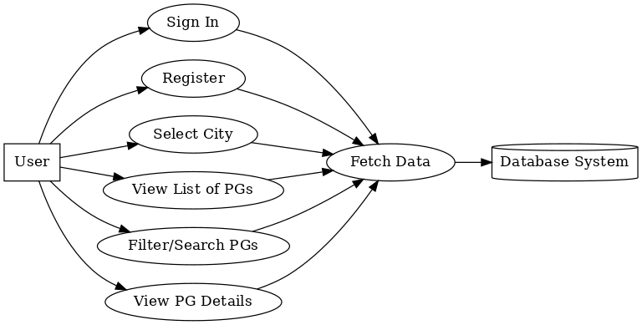

**5.10. Sequence Flow:**

**Sign In**:

* 1. User enters credentials and submits.
  2. Frontend sends the credentials to the backend.
  3. Backend validates the credentials with the database.
  4. Database returns the validation result.
  5. Backend sends a success/failure response to the frontend.
  6. Frontend displays the appropriate message.

**Register**:

* 1. User fills the registration form and submits.
  2. Frontend sends the details to the backend.
  3. Backend validates the data and stores it in the database.
  4. Database confirms the data is stored.
  5. Backend sends a success/failure response to the frontend.
  6. Frontend displays the appropriate message.

**Select City and View PG List**:

* 1. User selects a city.
  2. Frontend sends the city to the backend.
  3. Backend queries the database for PGs in the selected city.
  4. Database returns the list of PGs.
  5. Backend sends the PG list to the frontend.
  6. Frontend displays the list.

**View PG Details**:

* 1. User clicks on "View" for a specific PG.
  2. Frontend sends the PG ID to the backend.
  3. Backend queries the database for detailed information about the PG.
  4. Database returns the details.
  5. Backend sends the PG details to the frontend.
  6. Frontend displays the details.

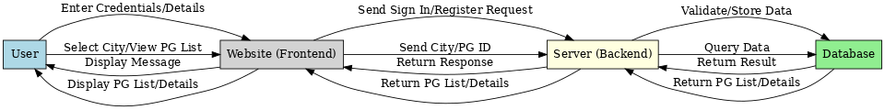

**6.PROJECT OUTCOME:-**

The development and implementation of **PG Life** resulted in a user-centric, efficient, and transparent digital platform that addresses the challenges associated with finding and offering PG accommodations. The key outcomes of the project are as follows:

**6.1. Simplified PG Search Process**  
The platform successfully streamlines the search for PG accommodations by providing users with advanced tools to filter properties based on their preferences, including:

* **Location**: Proximity to workplaces, educational institutions, and essential services.
* **Budget**: Flexible pricing options to suit different affordability levels.
* **Amenities**: Filters for features such as Wi-Fi, meals, air conditioning, and shared/private rooms.

This reduces the time and effort required to find a suitable PG, ensuring a seamless user experience.

**6.2. Enhanced Transparency and Trust**  
PG Life has improved transparency in the PG rental ecosystem through the following features:

* **Verified Listings**: Properties listed on the platform undergo verification to ensure accurate details.
* **Virtual Tours**: Visual insights into properties help users evaluate accommodations without physical visits.
* **User Reviews and Ratings**: Tenants can share their experiences, building trust and aiding future users in decision-making.

These features empower users to make informed choices, eliminating uncertainty and reducing dependency on intermediaries.

**6.3. Empowerment of Property Owners**  
The platform enables property owners to market their PG accommodations effectively by:

* Providing an easy-to-use listing interface to upload property details, images, and amenities.
* Offering tools to manage property availability and attract genuine tenants.
* Reducing vacancy periods by reaching a wider audience of PG seekers.

This ensures better property visibility, improved occupancy rates, and maximized returns for property owners.

**6.4. Data-Driven Insights and Personalized Recommendations**  
The integration of data analytics allows PG Life to deliver personalized experiences to users by:

* Tracking user preferences and search trends to provide tailored property recommendations.
* Generating insights for property owners to optimize their listings and align with market demands.
* Offering reports on popular locations, pricing trends, and user behavior, helping to bridge the gap between demand and supply.

**6.5. Improved User Experience through Technology**  
The outcome of the project highlights the successful integration of modern technology to enhance the user experience:

* **Location-Based Services**: Helping users find PG accommodations near key areas like colleges, workplaces, and public transport.
* **Secure Communication**: Enabling direct and safe interaction between property owners and seekers through built-in messaging tools.
* **Mobile Responsiveness**: Ensuring the platform works seamlessly across devices, including desktops, tablets, and smartphones.

This user-focused approach delivers convenience, accessibility, and efficiency for all stakeholders.

**6.6. Contribution to the PG Rental Ecosystem**  
PG Life has made a significant contribution to the PG rental market by:

* Creating a **centralized and reliable** platform for both property seekers and owners.
* Bridging the gap between increasing demand for affordable housing and the supply of PG accommodations.
* Reducing dependency on traditional, inefficient methods of property search and rental transactions.

**6.7. Long-Term Impact**  
The outcomes of PG Life are sustainable and scalable, offering long-term benefits such as:

* Enhancing the way individuals search for temporary accommodations, saving time and resources.
* Supporting urban mobility by providing flexible housing options for students, professionals, and travelers.
* Contributing to the digital transformation of the rental housing sector, making it more transparent, efficient, and accessible.

**6.8. User Interface :-**

**Home page**

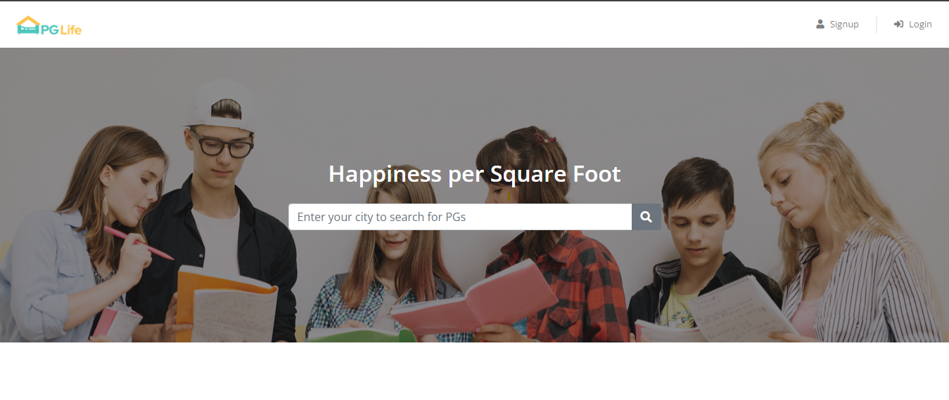

Fig 1

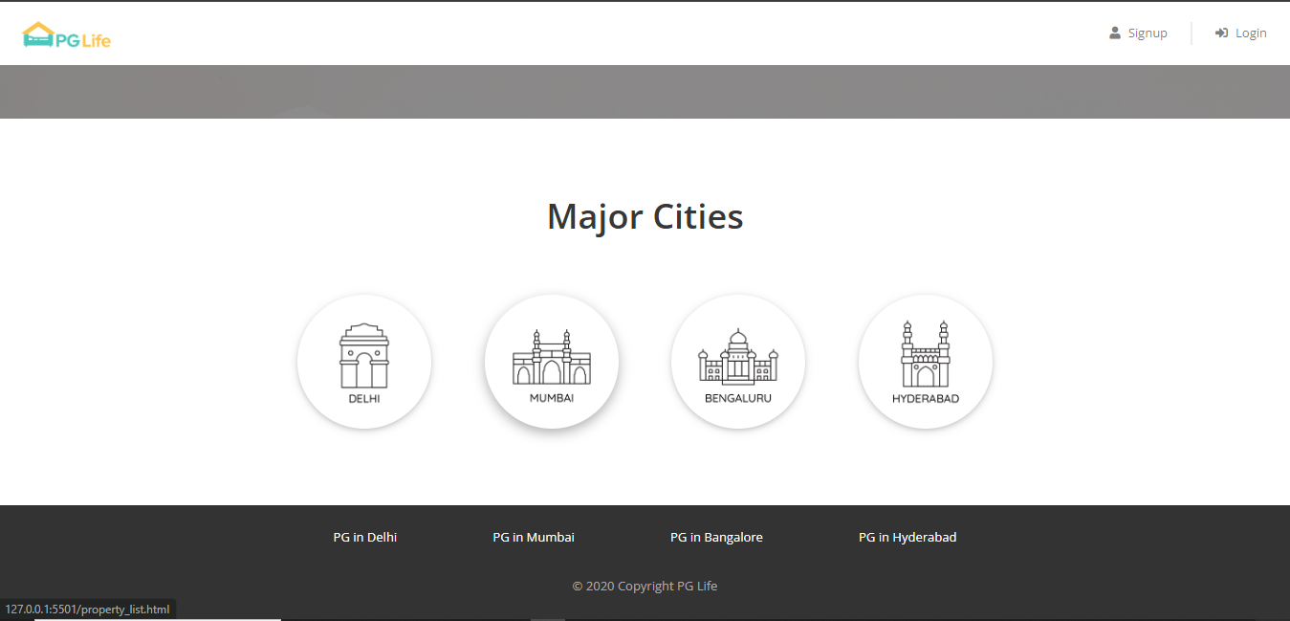

Fig 2

Explaination:-

The homepage of the PG finding website displays a list of major cities—Delhi, Mumbai, Bangalore, and Hyderabad. Users can select a city to view available PGs with essential details like name, price, ratings, and address. Clicking the "View" button leads to more detailed information about each PG, enhancing the user experience.

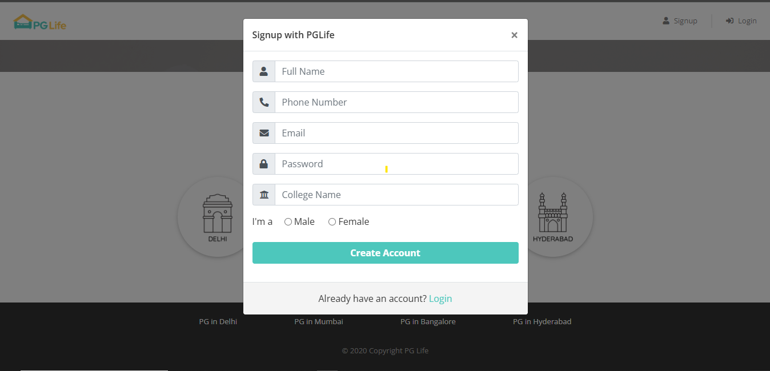

Fig 3

Explaination:-

The registration page allows users to create an account by providing essential details. It includes fields for **name**, **phone number**, **email address**, **password**, and **college name**. Users fill in these fields to register for the site, enabling them to access personalized features, manage PG searches, and receive updates or notifications.

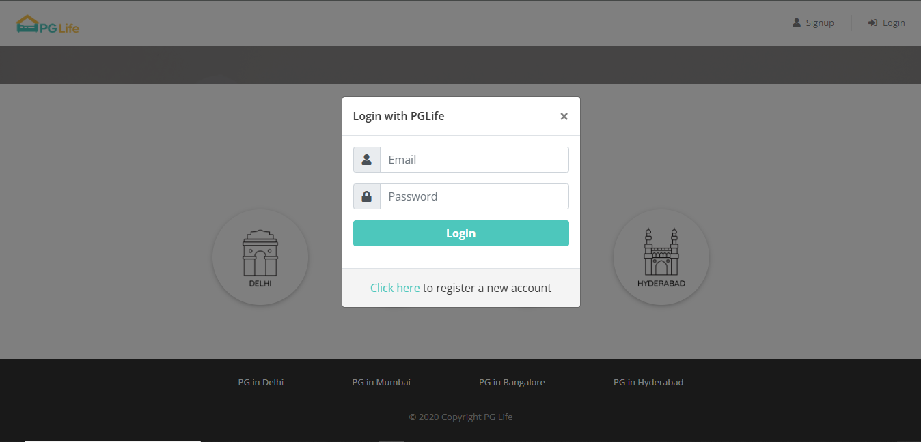

Fig 4

Explanation:-

The registration page allows users to create an account by providing essential details. It includes fields for **name**, **phone number**, **email address**, **password**, and **college name**. Users fill in these fields to register for the site, enabling them to access personalized features, manage PG searches, and receive updates or notifications.

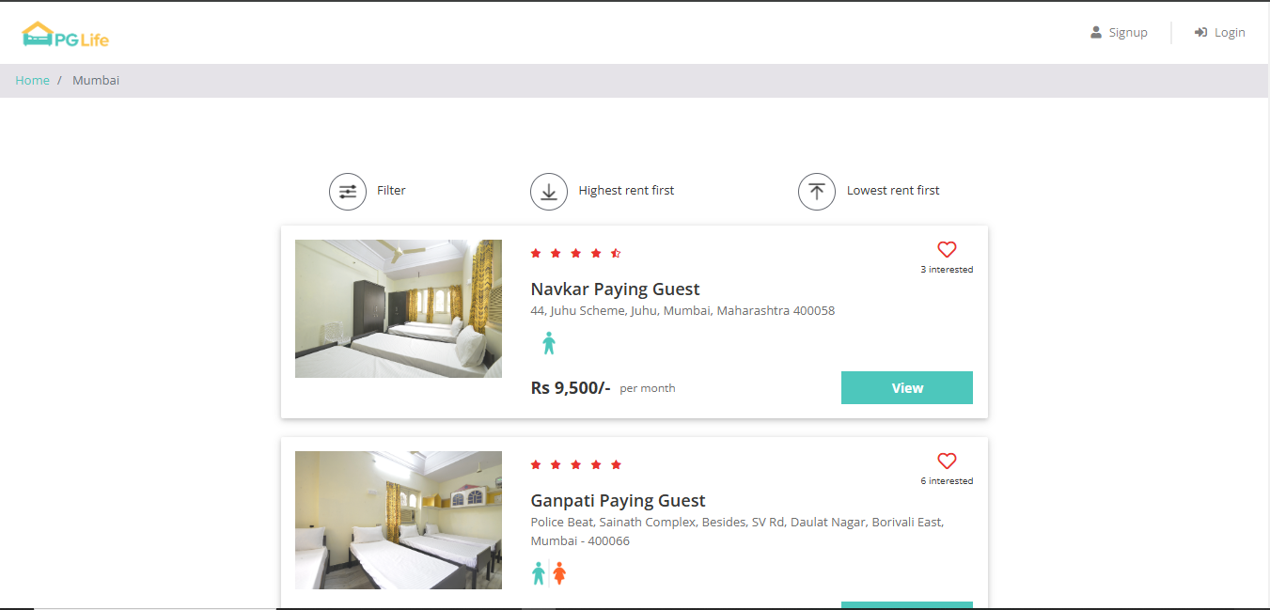

Fig 5

Explanation:-

The page is designed to help users quickly compare and choose between different paying guest options based on factors like rent and visual appeal. It presents a basic overview of each PG, encouraging users to click for more details.

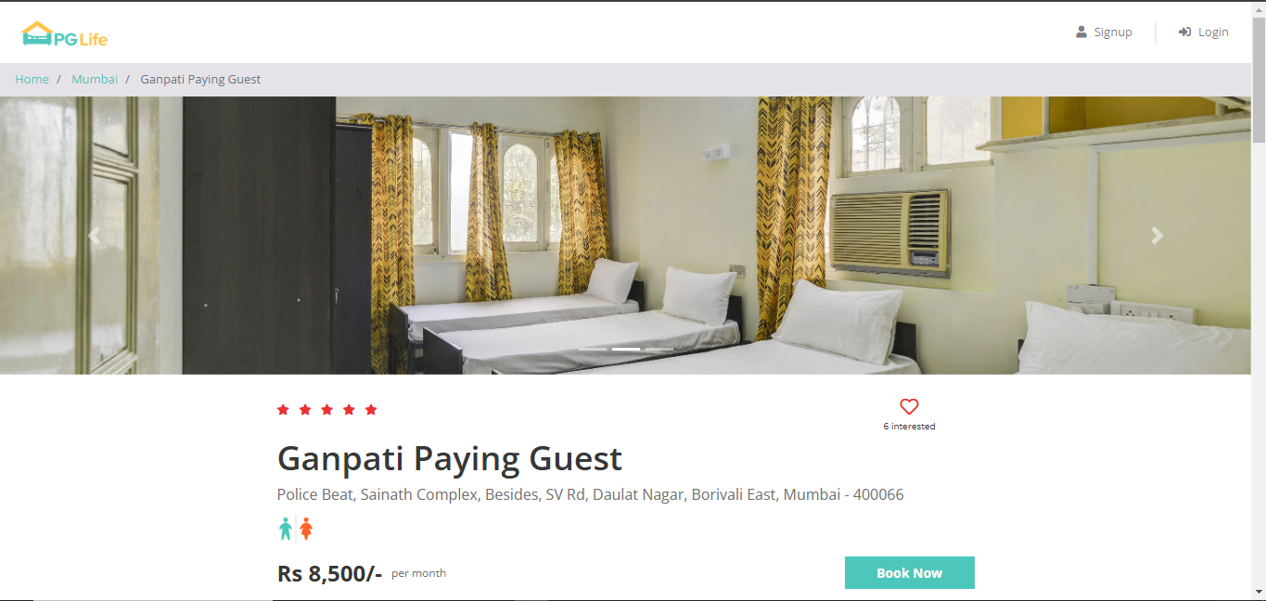

Fig 6

Explanation:-

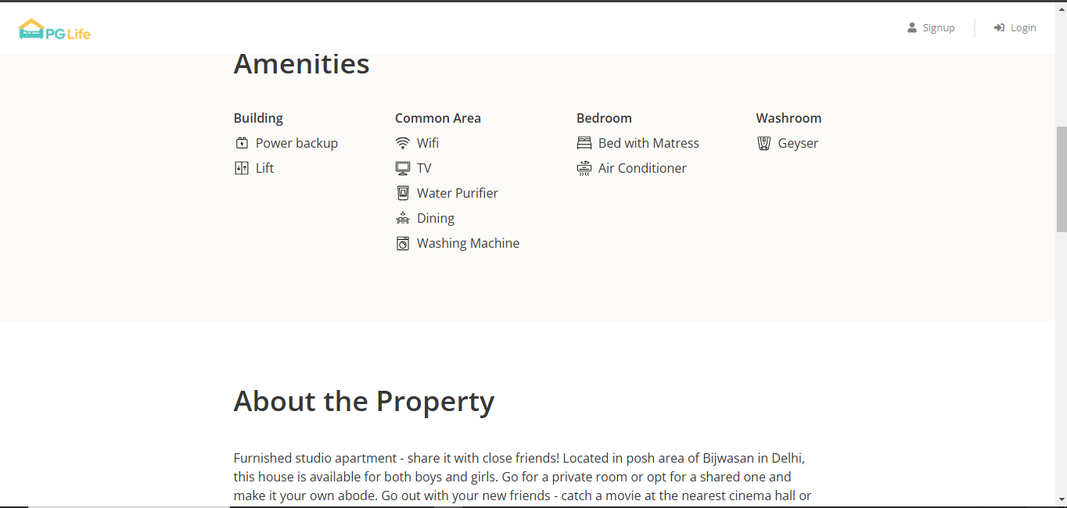

Fig 7

Explanation:-

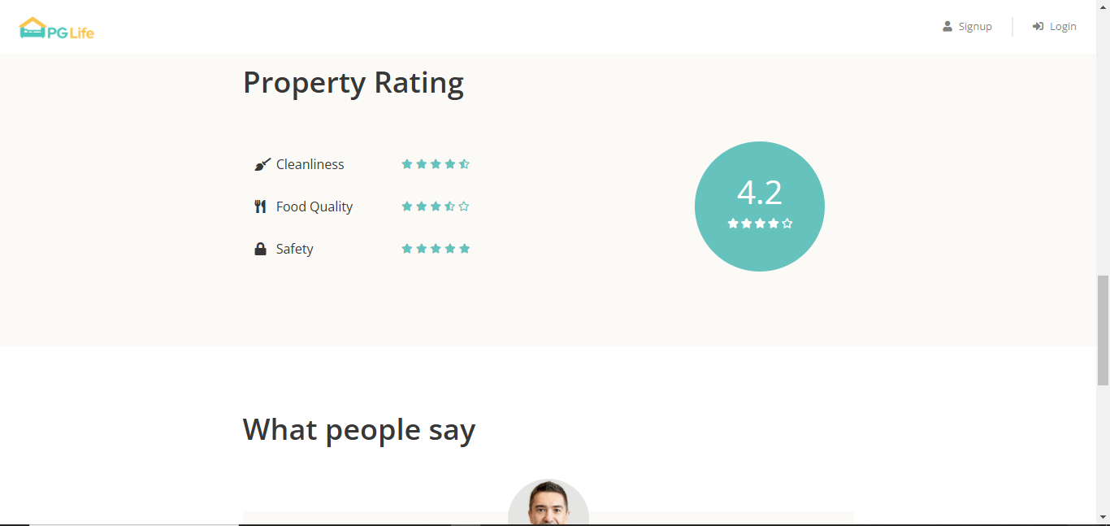

Fig 8

Explanation:-

**7.Conclusion**

PG Life has revolutionized the PG rental sector by creating a platform that seamlessly meets the needs of accommodation seekers and property owners. Through innovative technology and a focus on user experience, it simplifies the search and management of PG accommodations, offering features like personalized recommendations, virtual tours, and transparent pricing for tenants, while equipping property owners with tools to optimize listings and streamline operations.

By addressing market challenges such as inefficiency, lack of transparency, and fraud, PG Life has built trust and created a reliable ecosystem. Its use of data-driven insights and AI-powered features drives innovation and adaptability, setting it apart in a competitive market. With plans for expansion and added value services, PG Life is positioned as a leader in transforming the PG rental industry into a more efficient, transparent, and user-friendly space.

**8.References**

Housing.com. (2022). India's Rental Market Trends: 2022 Report. Retrieved from [https://www.housing.com](https://www.housing.com" \t "_new).

Kotler, P., & Keller, K. L. (2016). Marketing Management (15th ed.). Pearson Education.

Kumar, R., & Sinha, P. (2019). Enhancing trust through virtual tools in rental property searches. International Journal of Smart Technology, 14(4), 213-225.

Laudon, K. C., & Traver, C. G. (2020). E-Commerce: Business, Technology, Society (15th ed.). Pearson.

MagicBricks. (2023). The Future of Digital Property Listings. Retrieved from [https://www.magicbricks.com](https://www.magicbricks.com" \t "_new).

Ministry of Housing and Urban Affairs, Government of India. (2022). Urban Housing: Challenges and Opportunities.

National Sample Survey Office (NSSO). (2021). Migration Patterns in India and Housing Preferences.

Singh, A., & Sharma, V. (2018). Impact of digital platforms on the real estate rental sector in India. Journal of Technology Management, 12(3), 45-52.

W3C. (2021). Web Standards for Responsive Platforms. Retrieved from [https://www.w3.org](https://www.w3.org" \t "_new).

Gupta, S., & Verma, R. (2020). The role of location-based services in urban housing platforms. Proceedings of the International Conference on Digital Innovation, 8(5), 312-318.